VALUE ADDED PROBLEM 1:
Given a Binary Search Tree and a range [low, high]. Find all the numbers in the BST that lie in the given range. Note: Element greater than or equal to root go to the right side. Concept: Binary Search Tree

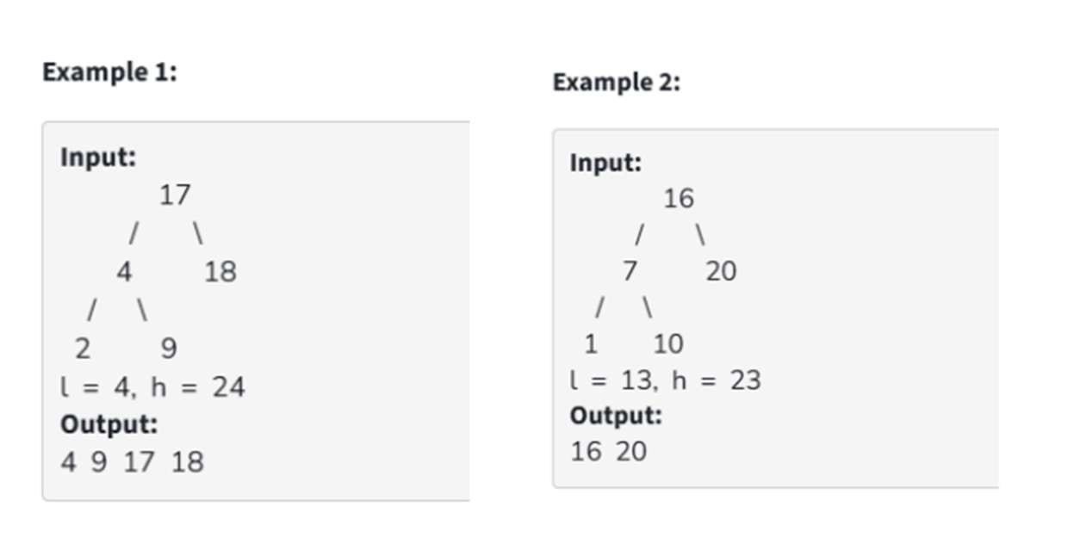
#include <stdio.h>
#include <stdlib.h>

// Node structure
struct node {
int data;
struct node* left;
struct node* right;
};

// Create node
struct node* createNode(int value) {
struct node* newNode = (struct node*)malloc(sizeof(struct node));
newNode->data = value;
newNode->left = NULL;
newNode->right = NULL;
return newNode;
}

// Insert into BST
struct node* insert(struct node* root, int value) {
if (root == NULL)
return createNode(value);

if (value < root->data)
root->left = insert(root->left, value);
else
root->right = insert(root->right, value);

return root;
}

// Print nodes in range
void printInRange(struct node* root, int low, int high) {
if (root == NULL)
return;

if (root->data > low)
printInRange(root->left, low, high);

if (root->data >= low && root->data <= high)
printf("%d ", root->data);

if (root->data < high)
printInRange(root->right, low, high);
}

// Main
int main() {
printf("KANHAIYA TYAGI \nPRN = 25070521157 \nSEC = C2\n");
// -------- Example 1 --------
struct node* root1 = NULL;

root1 = insert(root1, 17);
root1 = insert(root1, 4);
root1 = insert(root1, 18);
root1 = insert(root1, 2);
root1 = insert(root1, 9);

printf("Example 1 Output: ");
printInRange(root1, 4, 24);

// -------- Example 2 --------
struct node* root2 = NULL;

root2 = insert(root2, 16);
root2 = insert(root2, 7);
root2 = insert(root2, 20);
root2 = insert(root2, 1);
root2 = insert(root2, 10);

printf("\nExample 2 Output: ");
printInRange(root2, 13, 23);

return 0;
}
